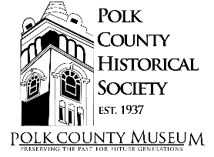
NOW HIRING
Executive Director

The Polk County Historical Society (PCHS) is seeking an Executive Director with organizational and leadership skills as well as computer familiarity as its leader and primary representative.

Roles and Responsibilities:
- Supervise the day-to-day functioning and operations of the Polk County Museum, PCHS, and volunteers
- Prepare and oversee the annual Budget
- Promote the PCHS's growth and programs
- Direct and participate in fundraising, and donor relationship cultivation
- Direct and facilitate grant writing
- Represent our organization in the community, and work closely with County and other civic leaders
- Oversee and direct the strategic plan as approved by the Board of Directors
- Directly report to the Board of Directors for the proper administration of all policies and operations of the Museum

This is a full-time position with compensation based on education and experience. Applications will be reviewed beginning April 20th. Position is open until filled.

Interested parties should submit a cover letter and resume along with up to three personal references to info@polkcountymuseum.org or mail to PCHS Executive Director Search, PO Box 41, Balsam Lake, WI 54810.

