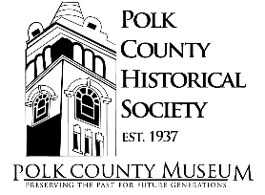
Hiring Museum Director for Polk County Historical Society

Position Overview:
The Polk County Historical Society (PCHS) is seeking a Museum Director who is responsible for the overall management and operations of the Polk County Museum. This includes but is not limited to overseeing the daily operations, exhibits, programming, and collections management. The ideal candidate will have experience in museum operations, nonprofit organizations, strong leadership skills, Computer skills and a passion for history.
Qualifications
- At least 3 years’ experience in museum operations or similar non-profit organizations
- Strong leadership and management skills
- Excellent organizational and planning abilities
- Strong written and verbal communication skills
- Familiarity with collections management and exhibit development
- Passion for history and dedication to preserving local heritage
- Fluent in basic technologies such as word documents, excel spreadsheets, and outlook email
- Ability to self-perform and be held accountable for performance
- Evening and weekend availability during “open” season
  - Open season is Memorial Day to Labor Day
  - Extremely flexible schedule during “off” season of Labor Day to Memorial Day

This is a full-time position and salary will be commensurate with experience. If you are interested in this opportunity, please submit your resume and cover letter along with three personal references for consideration to the Polk County Historical Society, PO Box 41, Balsam Lake, WI 54810

