Archaeology Lecture: Friends of Aztalan State Park
Lecture Title:
The Milwaukee Public Museum Aztalan Excavation Photographs:
A Photographic Journey through the 1919, 1920, and 1932 Samuel A. Barrett Excavations at Aztalan
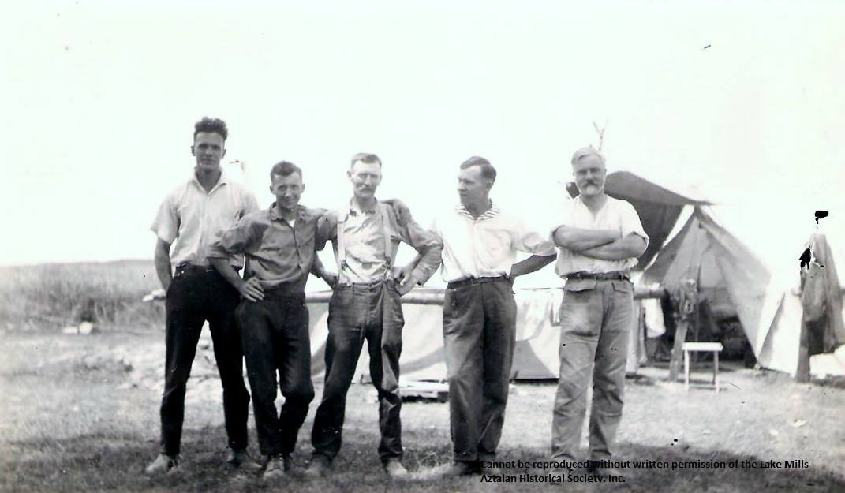
Please join archeologist, museum curator, and Aztalan State Park Naturalist Kurt A. Sampson as he takes you on a photographic journey of the Milwaukee Public Museum’s Aztalan Excavations.
In 1919, 1920, and again briefly 1932, the Milwaukee Public Museum lead by Samuel A. Barrett conducted the first professional and systematic excavations of any site in the state of Wisconsin at the Aztalan site. Samuel Barrett was the first formally trained North American archaeologist to work in the state of Wisconsin. During his three excavations at Aztalan over 500 black and white excavation photographs were taken that help detail certain aspects of the sites unique prehistoric occupation. Taken from several portions of the site, these photographs help to illustrate Barrett’s excavations and help to confirm and disprove many of the sites earlier discoveries and assumptions made by earlier Aztalan site explorers such as Judge Nathaniel Hyer, Increase Lapham, and T.H. Lewis. Samuel Barrett also identified many new aspects of the site and its mysteries. Many of these excavation photographs are highlighted in Barrett’s pioneering and classic work entitled Ancient Aztalan published in 1933.
* Many new recently discovered photographs taken of these excavations have been discovered in the Lake Mills-Aztalan Historical Society and will be shown for the first time to the general public.
Time: 11:00 AM Saturday, February 1st 2014
PLACE: Fargo Public Library – Lake Mills, WI at 120 E. Madison Street, Lake Mills

