Great Fire of 1871 in the Belgian Settlements – Fact Sheet

Belgian Heritage Center Contacts
Barb Chisholm – mschis1946@gmail.com, 920-493-5969
Sandy Orsted – sorsted@hoffman.net, 920-493-2850
Ann Jinkins – jinkins.ann@gmail.com, 920-743-1189
Rebecca Derenne – rdhealth6@gmail.com, 920-389-1768

General Information
- Firestorm occurred on October 8, 1871, the same day as the Chicago fire but far more destructive in NE Wisconsin. At least 1,500 people died (possibly up to 2,500) in Wisconsin vs. 300 in Chicago. Thousands more left homeless and destitute. Almost 1.3 million acres destroyed. Most casualties were on the west side of the bay which was more populated at that time. Estimated 200-300 deaths on the east side of the bay including the Belgian settlements. Exact death toll is unknown.
- Commonly referred to as the Peshtigo Fire where the greatest loss of life occurred, but both sides of the bay of Green Bay were impacted on the same day.
- Deadliest fire in US history by far and one of the worst natural disasters.

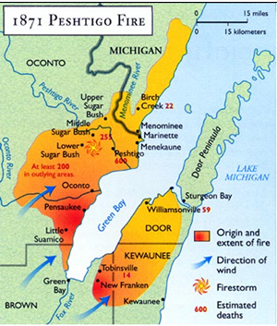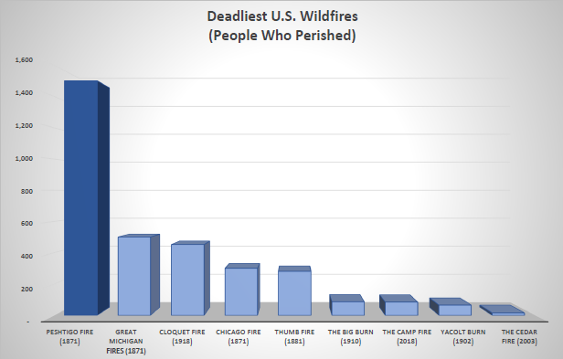
map source: https://www.weather.gov/grb/peshtigofire; chart by BHC using data from Green Bay Press Gazette, Wikipedia

Information about the Great Fire in the Belgian Settlements
- Belgians started immigrating to NE Wisconsin in 1853 settling in Brown, Kewaunee and southern Door counties. They were drawn to the area by the opportunity to own large farms, which was not possible for them in Belgium, but they first had to clear the land of massive trees. Early economy was based on logging and shingle making. By 1871, Belgians established several small, but growing communities that laid in the path of the fire.
- Risk factors:
  - Weather and Dry Conditions. Across the US, 1871 was exceptionally dry and hot; fires were common during the summer and fall; no significant rain in this area after July 8.
  - Presence of flammable material. Reliance on trees as economic base and use of wood and byproducts for practically everything - buildings, furniture, fencing, corduroy roads; sawdust for beds and dust control. Slashings and sawdust accumulated in forest and around buildings.
  - Use of fire for daily tasks. Cooking, smoking meat, rendering lard, scalding chickens, etc.
- Fires, including ground fires, broke out throughout in the Belgian settlements east of the bay for months; many buildings of various types lost before October 8.
- Creeks and wells were drying up making it harder to contain the fires. Smoke from frequent fires made it difficult to see and breathe.
- On October 8, weather systems produced high winds. High winds fed fires, triggering vicious cycle of wind feeding fire, and fire creating more wind. Survivors described “tornados of fire” caused by the vortex of the fires pulling debris and fire high into the air.
  - Note – the fire did not “jump the bay.” Conditions were similar in both locations and fires on both sides of the bay were triggered by the same weather systems.
- Effect was transformational for survivors and development of the Belgian communities:
  - Destroyed the logging economy
  - Facilitated shift to farming economy – the reason Belgians came to Wisconsin in the first place; agricultural economy and family farms handed down through generations to this day
  - Brick homes – after the fire, log homes had a brick veneer for fire resistance and a gable window as a look out for fires; brick reminiscent of homes in Belgium, many still in use today
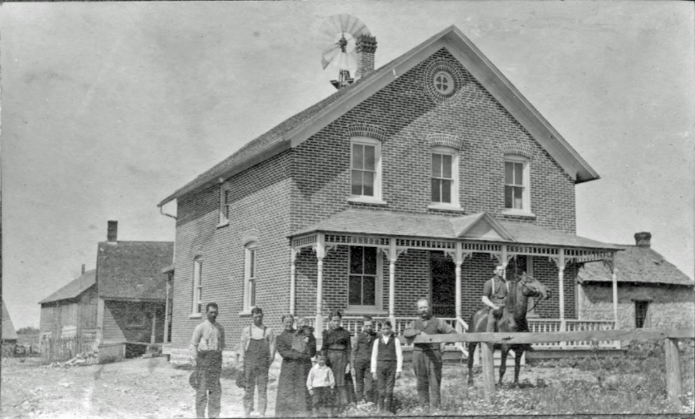
photo source: Belgian Heritage Center

Scope of Video
Much has been written about the effect of fires on October 8, 1871 in the Peshtigo and Chicago areas. The impact of the fire in the Belgian settlements has been somewhat overshadowed by the fires in more populated areas. The video explains the causes of the fire, the immediate impact on the Belgian settlers, and the transformation of the Belgian communities that occurred through rebuilding.

Belgian Heritage Center
- Established in 2010 at former St. Mary of the Snows campus near Brussels, Wisconsin
- Located in Namur National Landmark Historic District in southern Door County, first rural community in the US to achieve this designation due to prevalence of historic homes, farms and roadside chapels
- Mission: To preserve and share the history and legacy of the immigrants of the Belgian Settlement Area through programs and exhibits on the campus of the Belgian Heritage Center and by facilitating the efforts of others to preserve and share Belgian heritage for future generations.
- Belgian settlements include roughly 150 square miles in the area roughly bordered by Green Bay, Sturgeon Bay and Luxemburg/Casco.
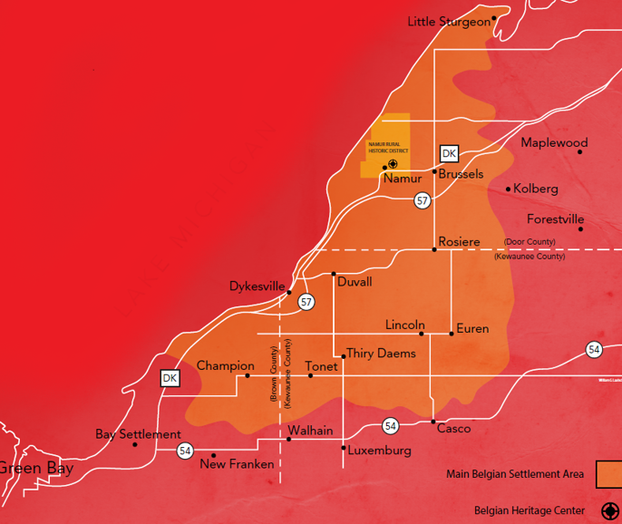
map image source: Belgian Heritage Center

