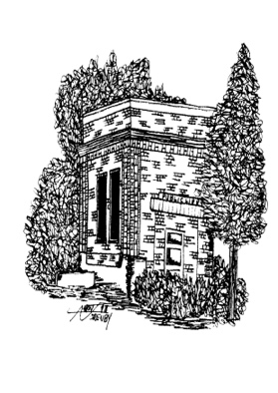
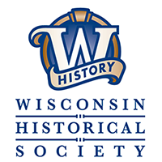
“Pop-up” Collections Care Workshop

SATURDAY, AUGUST 4, 2018

Hosted by the Blanchardville Historical Society
Blanchardville Historical Society
at the Blanchard Hall
204 South Main St., Blanchardville, WI 53516
(Parking on Main Street and behind Blanchard Hall at 208 Mason Street)

Learn about the basic essentials of collection care, how the Blanchardville Historical Society comprehensively revolutionized their collections care systems and how you can too.

9:00 Registration and Refreshments Coffee, Juice, breakfast rolls, & fruit

9:30 Welcome and Introductions

10:00 The Blanchardville Historical Society Collections Renovation Project Danielle Benden, Owner of Driftless Pathways and the Blanchardville Historical Society Board.

10:45 Break - Refreshments

11:00 Round Table Discussions Bring your questions and puzzling collections conundrums! Ask questions and get answers about the challenges you’re facing at your historical society or museum. Danielle Benden will guide discussion and offer resources for assistance.

12 Noon Lunch – Blanchardville Hall
Egg salad and ham sandwiches, potato salad, coleslaw, fresh fruit, cheese tray, and assorted desserts.

1:00 Tour
- Visit the Blanchardville Historical Society Museum (across the street from Blanchard Hall) for a guided tour of the museum renovation project.

Cost: $20

Registration Deadline: July 28, 2018

Send Registration form and $20 by July 28th to Blanchardville Historical Society

Questions? Becky Johnson, Phone 1-608-523-1507 or email noodleshome@tds.net

Detach and mail with payment -------------------

Registration Form Mail to: Blanchardville Historical Society
PO Box 62
Blanchardville, WI 53516

Local History Meeting, Blanchardville August 4, 2018 $20

Checks should be made out to: Blanchardville Historical Society
Name Organization / Affiliation

Address City, State, Zip

Phone Email

