The Sauk County Historical Society presents
Sunday in the Cemetery
LIVING HISTORY TOUR
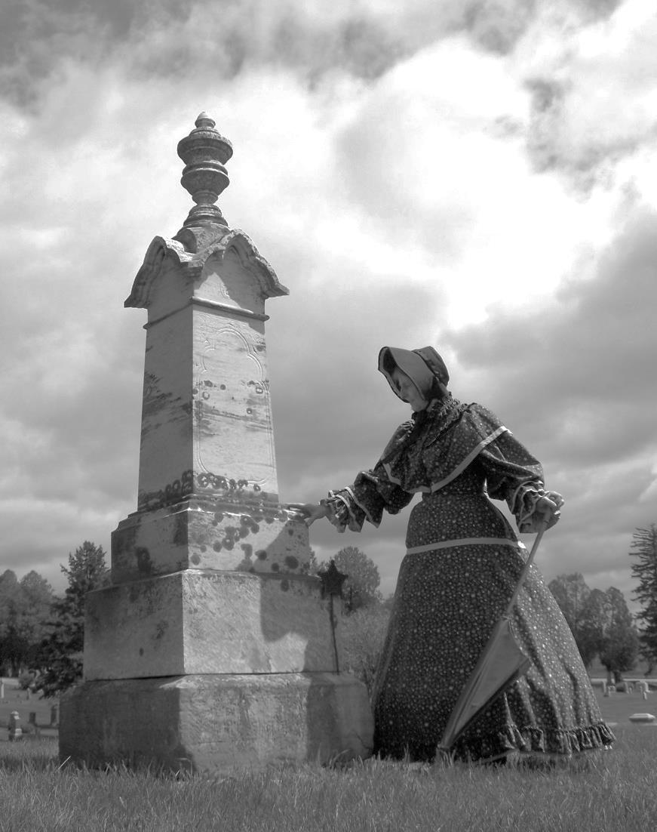
Walnut Hill
Cemetery

Baraboo
Sunday, June 28
2 p.m.

Guided tours to nine graves and mausoleums with costumed reenactors.

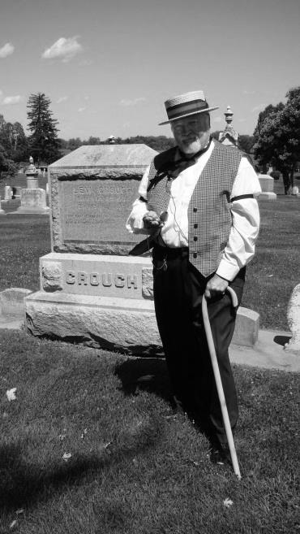
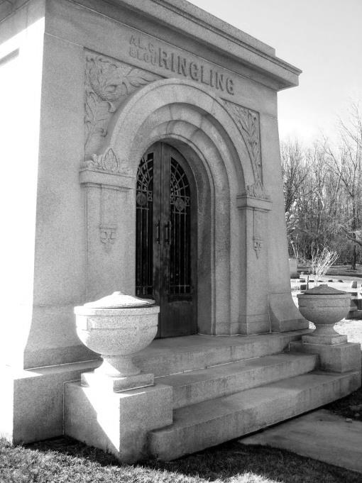
Tickets - $8.00
Available at the cemetery
on the day of the tour

Help celebrate the centennial
of the Al. Ringling Theatre
with this special circus
themed tour!

