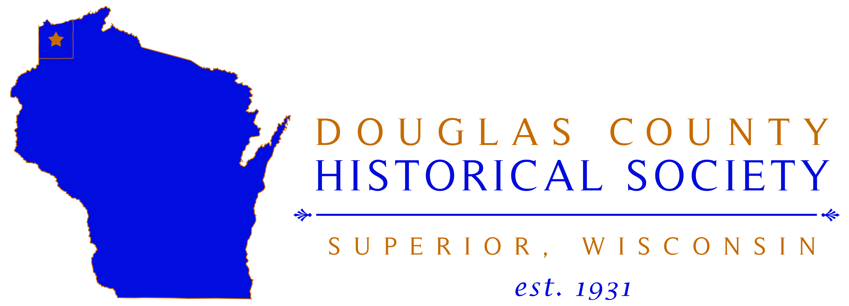

This position is open to Resumes from: March 7th, 2017 – March 24th, 2017
Submit cover letter and resume to DCHS@DouglasHistory.org or mail it to the attention of Tony Tracy, Executive Director to Douglas County Historical Society, 1101 John Ave., Superior, WI 54880. Please do not apply in person.

Curator/Assistant Director
FT/PT/Temp: Part Time
Openings: 1
Location: Superior, Wisconsin
Job title: Curator/Assistant Director
Title Reports To: Executive Director
Education: BA in History or other related field with an emphasis on historic collections, artifacts and research. (Preferred)
Experience: Minimum of 1-2 years working in a history museum setting. Strong experience level will be considered in place of/or in addition to a BA Degree.
Hours: 12:00 PM – 5:00 PM Tuesday-Friday (Additional hours for events, exhibit openings, etc… will be available on a need basis.) There are no benefits provided with this position.
Job Summary:
The Douglas County Historical Society Curator will organize and oversee exhibitions, both current and future. The Curator will develop ways in which objects, archives and artwork can be interpreted, through exhibitions, publications, events, audio-visual presentations and History Theater programs. This work involves organizing exhibits, arranging restoration of artifacts, identifying and recording items and dealing with public inquiries. In addition, the Curator will be required to work with other colleagues in areas such as conservation, education, design and marketing. The person in this position also will act as Assistant Director and handle all questions and museum business in the absence of the Executive Director at the facility.

Responsibilities & Duties:
- Develop and organize new collections to expand and improve educational and research capabilities at DCHS.
- Extensively research all artifacts used in all exhibitions and presentations.
- Maintain records, cataloguing of acquisitions and make recommendations and plans to improve the current systems.
- Collaborative effort to work with other local, regional and national historical institutions.
- Properly preserve all collection materials.
- Raise funding and apply for Grants. Provide budget for all proposed exhibitions.
- Write text for wall labels, wall boards, print brochures, etc.
- Perform research as need per Executive Director.
- Assist with marketing materials
- Assist in community outreach and education school programs.
- Assist Executive Director in other projects as needed.
Key Skills for Curators:
- Excellent written and verbal communication skills.
- Safety is always job #1.
- Great customer service attitude and experience.
- Ability to organize, present and communicate messages effectively
- Excellent project management
- Knowledge of Grants and other funding for cultural projects.
- Knowledge of fundraising.
- Great Team working Skills
- Computer Skills including mastery of Word, Excel, PowerPoint and email.

Physical Requirements:
Must be able to perform all physical duties associated with museum work. Must be able to lift at least 40 lbs. and have the ability to safely climb ladders and work from an elevated platform.
Position(s) Supervised:
Supervise other paid and volunteer workers and temporary staff as needed.

The Douglas County Historical Society is an equal opportunity employer.

