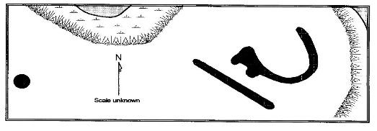
Effigy Mounds Tour of Dodge County Wisconsin
Hosted by: The Friends of Aztalan State Park & Dodge County Historical Society
Please join Wisconsin Archeological Society President, Aztalan State Park Educator, and DCHS Museum Curator Kurt Sampson for a comprehensive tour of several of Dodge County’s unique Indian Effigy Mound Sites.
When: Saturday, October 12th 2013 10:00 AM to 5:00 PM
Tour Cost: $10.00 Adult & No Children Under 10
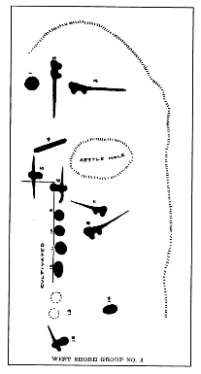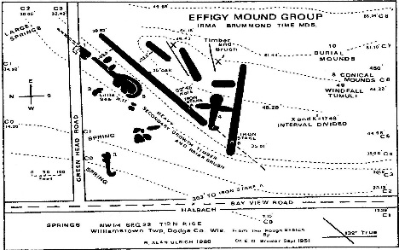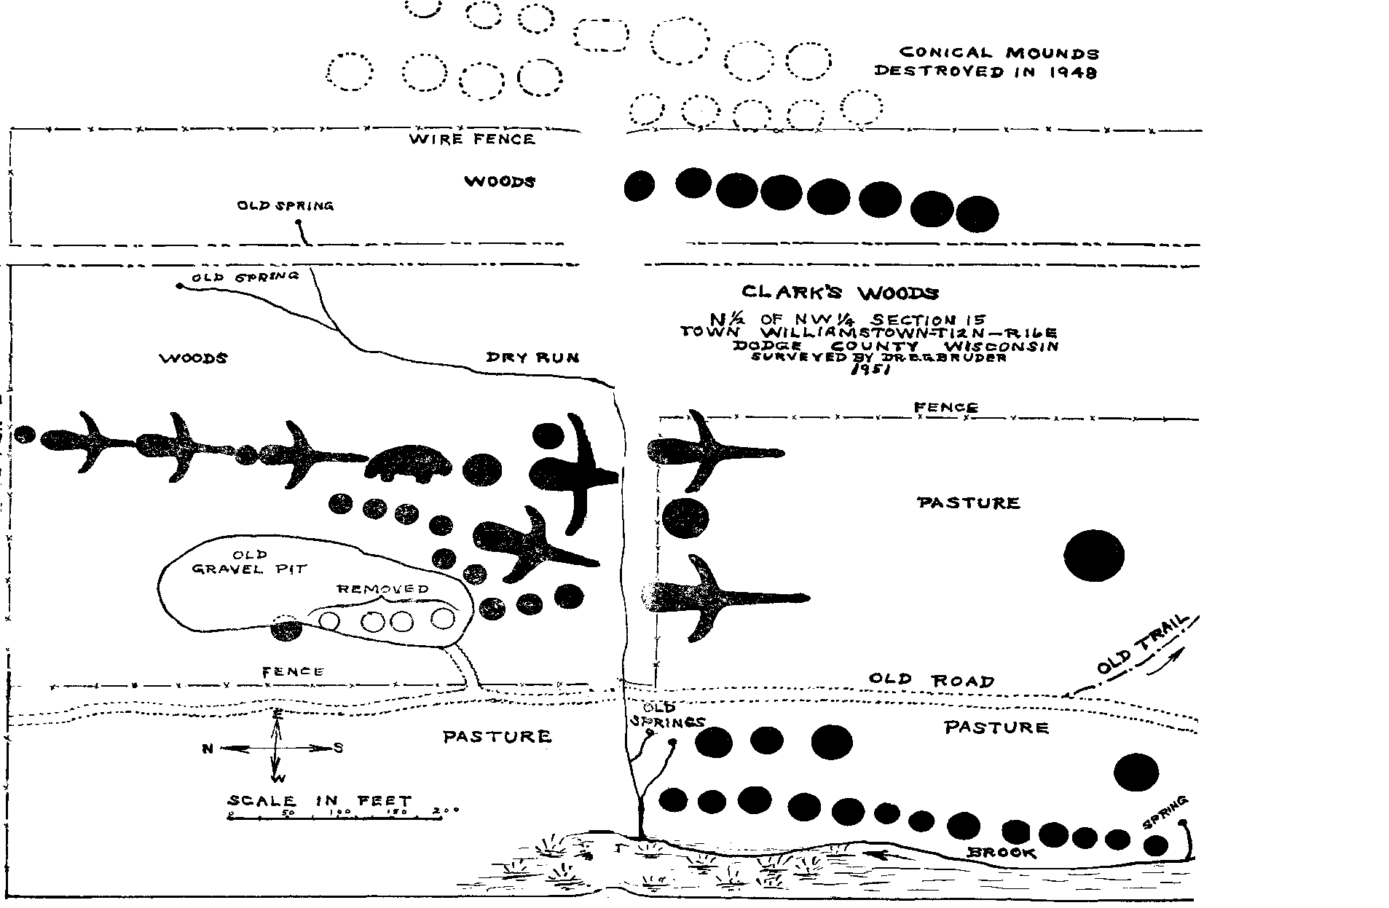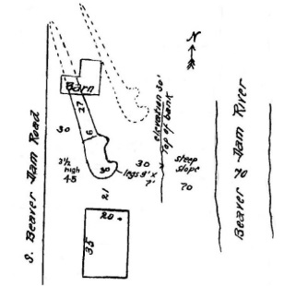
*Because of Limited Bus Space, Trip Limited to the first 50 People*
RSVP by Wednesday, October 9th to: ksampson2@wi.rr.com or Call 414-405-4367
Please meet at the Dodge County Historical Society Museum Located at 105 Park Ave Beaver Dam WI
Assembly Meeting at DCHS Museum: 9:30 AM & Bus Departs at 10:00 AM Sharp
This bus tour is expected to last from 10:00 AM to roughly 5:00 PM.
**Due to the physical nature of this trip, with hiking over some rough terrain, people with disabilities, children under 10 years of age, and the elderly are not encouraged to attend.
All tour cost proceeds to cover the cost of the bus rental.
Please dress accordingly for the weather forecast which includes: Rain gear, sturdy hiking boots, trekking poles, Bug spray, and long pants.
Please bring a bag lunch, a snack, and something to drink. We will be stopping for lunch at Nitschke Mounds County Park along the tour. There is a primitive bathroom at the park.
Mound sites visited will include: Davitt, Propst, Nitschke, Horicon, Hwy28, Koch, Brummond, Clark, Kolterman, Fox Lake, and Lake Emily. (Time Permitting)

