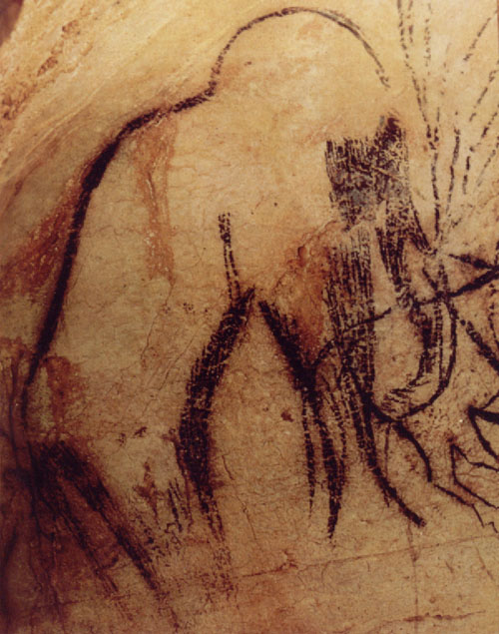

**The Persha Mammoth Exhibit**

**Dodge County, Wisconsin - 10,000 BC & The Paleo-Indian Legacy**

**Dodge County Historical Society Museum**

**105 Park Ave Beaver Dam WI 53916**

**Special Exhibit Opening: Saturday, April 5th 2014**

**1:00 PM – 4:00 PM**

**A Special Exhibit by Crystal Ellcey & Kurt A. Sampson**