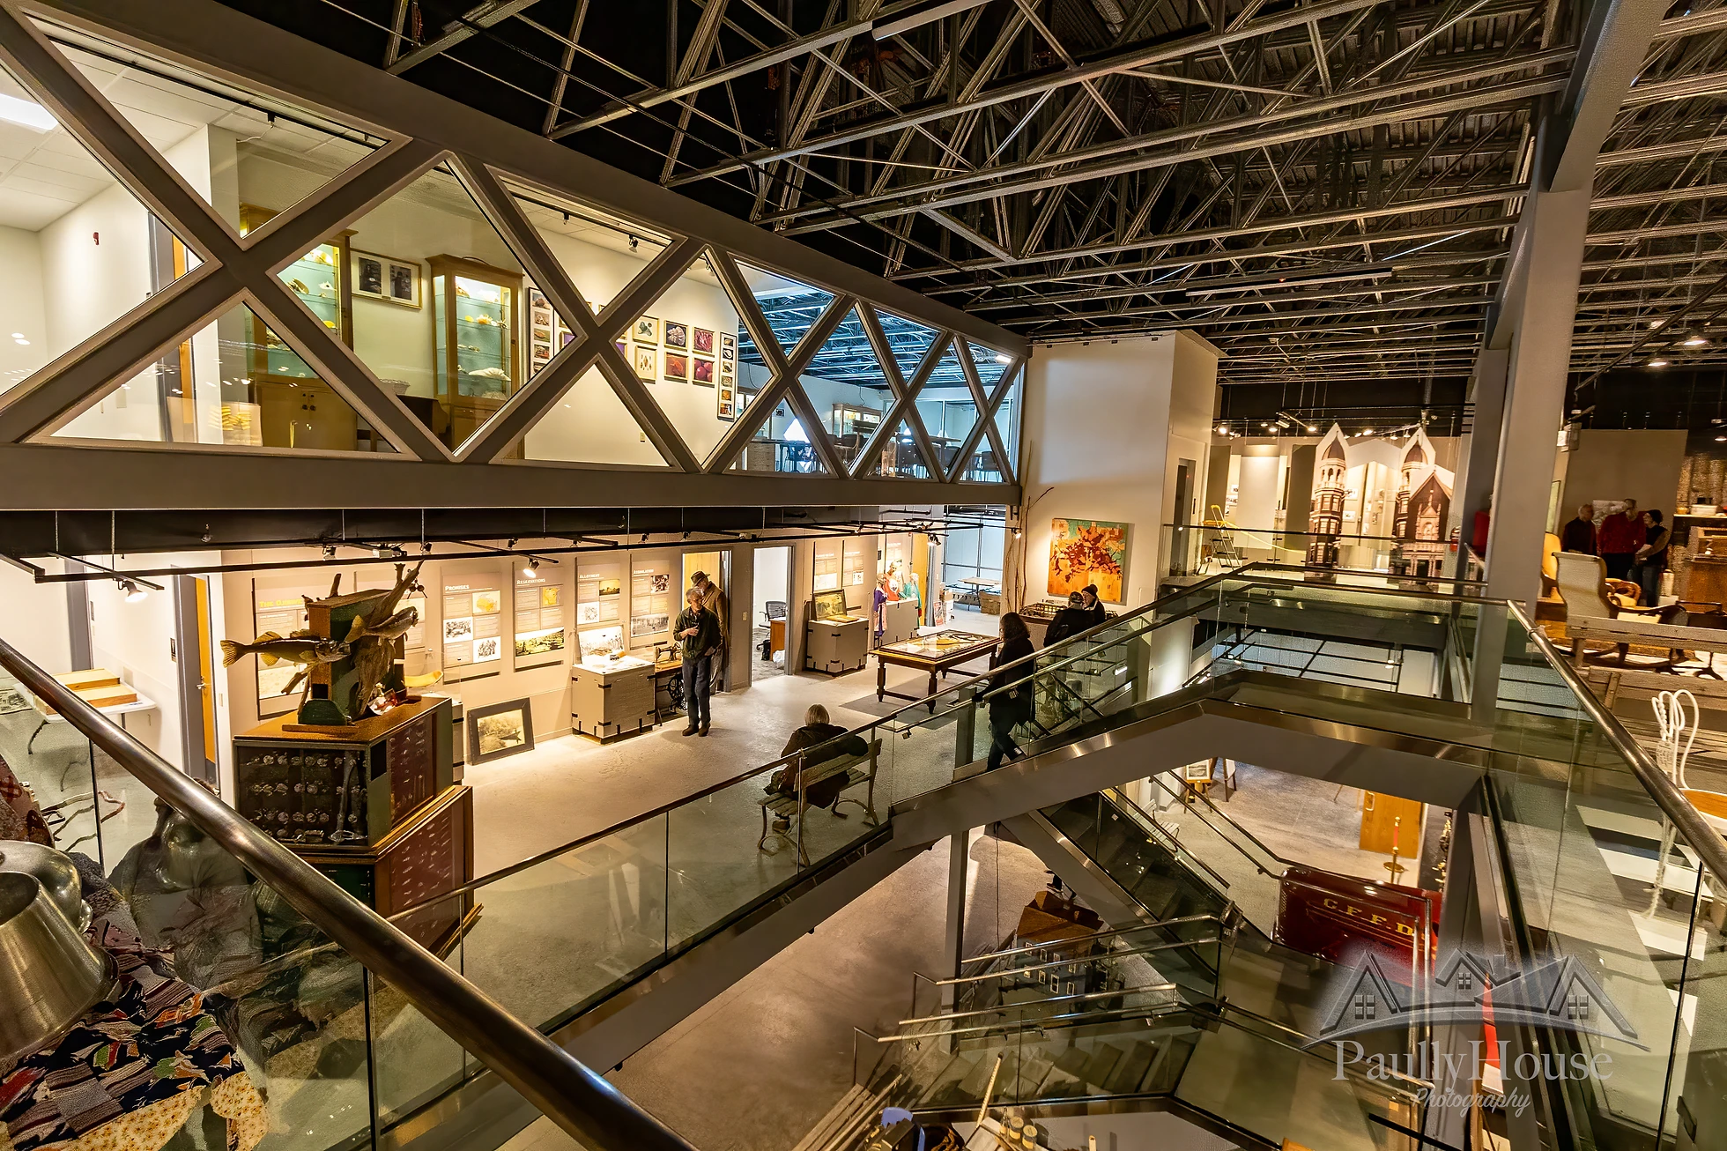  - March 14  Northwest Wisconsin Museum Consortium  Mini-Conference  With sessions covering fundraising, non-profit management, strategic planning, local history research, digitization, managing a small archive, and exhibit building on a shoe-string budget, you don’t want to miss this one-day conference. Held at the newly opened Chippewa Area History Center, our conference room is beautiful and state of the art. This is a great opportunity to tour the new museum. All for just $15. Reserve your spot by calling 715.458.2080 or emailing museum1@chibardun.net. | Informed, Engaged Presenters  ____  Interesting, Timely Topics  ____  Quarterly Meeting  ____  Reasonably Priced  ____  Includes Lunch and Snacks  Chippewa area History Center  12 Bridgewater Ave.  Chippewa Falls, WI  715-723-4399  chippewaareahistorycenter.org  March 14, 8:30 am – 3:30 pm

