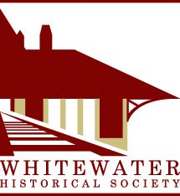
Whitewater Historical Society
MUSEUM OPEN HOUSE
SUNDAY, MAY 22, 1:00-4:00 p.m.
The Whitewater Historical Society will hold an Open House at the Depot Museum, 315 Whitewater Street, Whitewater, on Sunday, May 22, 1:00-4:00 p.m. The open house is a celebration of the completion of the eight exhibits in the permanent Whitewater history gallery. These exhibits cover the history of Whitewater, pre-1837—c.1990 and the history of the depot building. Members of the Board of Directors of the historical society will be on hand to talk with the general public about the society, its museum, and the exhibits.

Special Attraction: The society is also fortunate to present a special exhibit in the temporary gallery. Don West has loaned his Whitewater rail yard model for the society to display this summer. The large model depicts the rail yard from 1890 to 1910 and includes the depot, other buildings, structures, tracks, and trains. The society is also showing railroad photos from the same era.

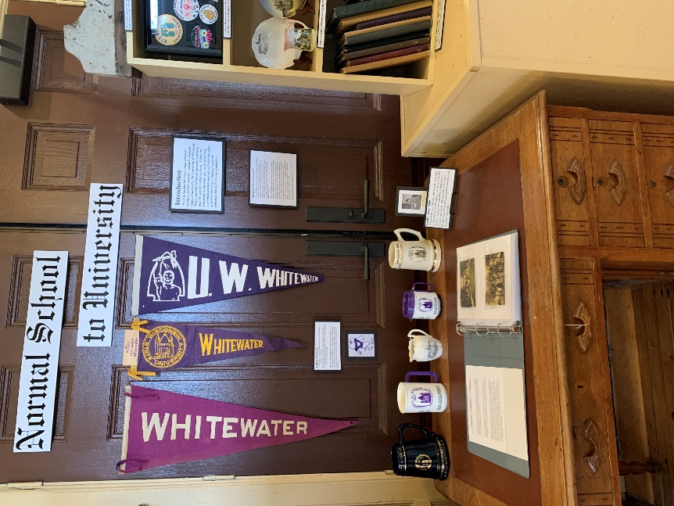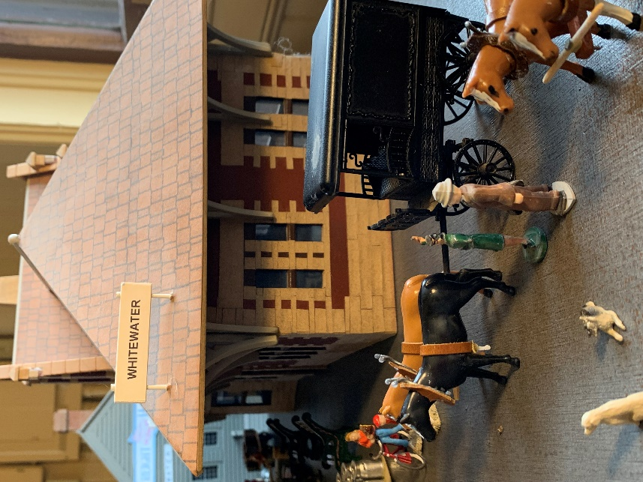

Left: New exhibit, “Normal School to University”
Right: Part of Don West’s c.1900 rail yard model

