In this issue:
35TFW Records Bonanza Month
- 1St Lt. Lee R. Howard
Ken Redeker Comes Home To a Real Family Christmas
615 TFS, 35 TFW, Phan Rang AB, Sep 1968
“Spooky” Gunship AC-47D Shot Down, 14 Feb 1968
700 Combat Mission - Capt. Ronald Miller
No. 2 Squadron strikes by night
Big Airlift Ends at Song Be
Doug’s Comments

35TFW Records Bonanza Month
(The Phan Fare, The Happy Valley Weekly, May 23, 1971)

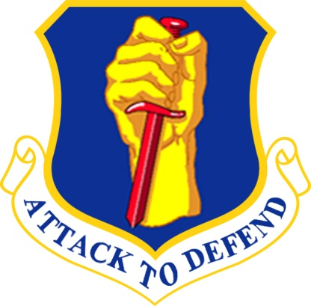
It took the efforts of everybody pulling together, but when it was over it couldn’t be doubted: March was a bonanza month for the 35th Tactical Fighter Wing (TFW) here.

The 615th Tactical Fighter Squadron (TFS) set a Wing aerial record for the number of sorties and flying hours; the Propulsion Branch of the 35th Field Maintenance Squadron (FMS) doubled their normal output and turned out 44 rebuilt jet engines; and the 435th Munitions Maintenance Squadron (MMS) processed and loaded nearly six million pounds of ordnance, also a record.

Of course, each milestone is interrelated. Without the jet engines functioning properly, the flying squadrons would not be able to fly a single combat mission, and without combat missions to fly, the munitions men would not be able to load the bombs and shells.

The 615th TFS, one of the four F-100 Super Sabre squadrons in the 35th TFW, shattered the Wing’s monthly flying totals by logging an undisputed 1189 combat hours on their aircraft for the month of March. For comparison, they flew 887 hours during February. The March high flyer for the 615th was First Lt. Lee R. Howard who flew 42 missions for a total of 66.9 combat flying hours.

For Lt. Col. Paul Kasarda, March 1971 will be remembered as a very special month, for it was his last month as commander of the 615th TFS. Immediately following the milestone ceremony at the flightline with Lieutenant Howard, Lt. Col. Kenneth S, Schroder took command of the 615th from Colonel Kasarda who moved up to take over as the Wing’s assistant deputy commander of Operations.
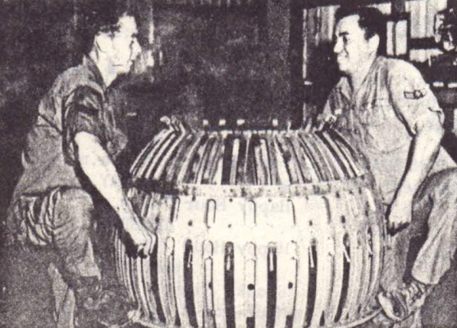 | 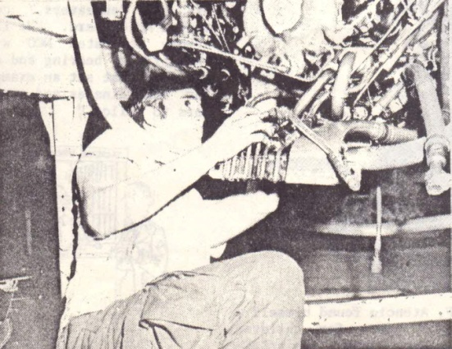
ONE, TWO, THREE...LIFT --- Sgt. William Shonk (left) and Airman 1st Class Abelo Solis check out the freedom of movement in the afterburner section of the J-57 jet engine used in the F-100 Super Sabre fighter aircraft of the 35th Tactical Fighter Wing here. (Photo by Airman 1st Class Wayne Chapman) | GEAR ASSEMBLY -- Sgt. Andy McClendon installs the angle drive dear on a J-57 jet engine of the 35th Tactical Fighter Wing’s F-100 Super Sabre fighter. The gear drives the jet’s oil pump and the accessory housing assembly. (Photo by Airman 1st Class Wayne Chapman)

Col. Kasarda stated, “The month’s accomplishments couldn’t be reached without the total determination from everybody in the 615th TFS. Good leadership and good supervision by the noncommissioned officers and honest day’s work with everybody pulling together made this bonanza month possible. We established a goal and we were determined to reach it. The combat hours record for March is an all-time high for a tactical fighter squadron in South-east Asia, and each man in the 615th deserves credit for the part he played in achieving this milestone.”

The 35th TFW’s four F-100 squadrons flew 4,374 total flying hours during the month, bettering February’s figure of 3,232 hours by 1,142 hours. A significant portion of these combat hours were flown in close air support of friendly ground forces in the Lam Son 719 and Vietnam-Cambodia-Laos tri-border area. The wing’s 4,374 flying hour mark could also be achieved by one man if he took off at the stroke of the New Year, Jan. 1, and stayed in the air until 6 a.m. July 2 - more than six months.

But the pilots couldn’t fly without engines in their fighters, and the jet engine ship pulled their weight and then some during the month.

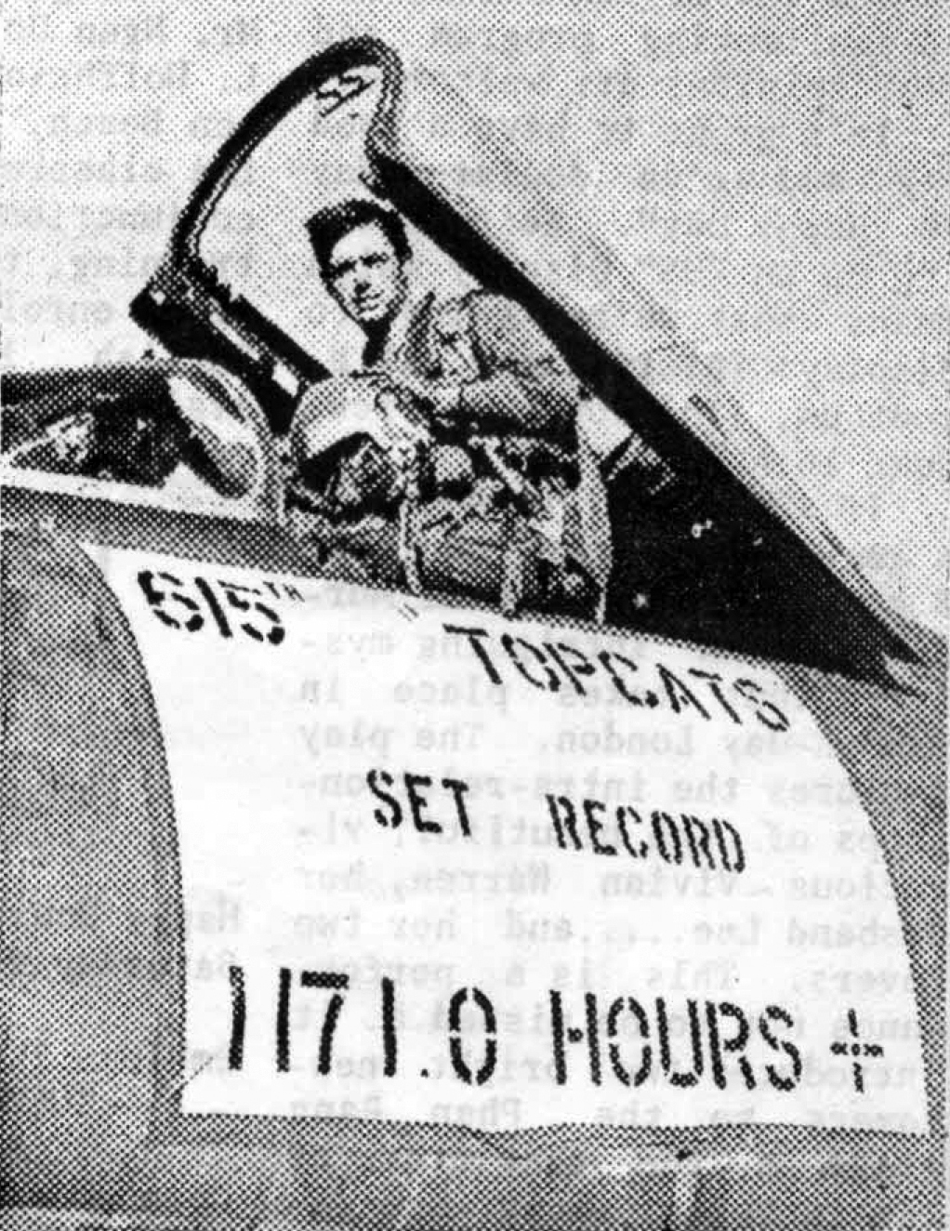 | 615TH TOPCAT - - “Topcat” of the 615th Tactical Fighter Squadron “Bobcats”, First Lt. Lee R. Howard displays his squadron’s accomplishments during March after touchdown at Phan Rang AB after completing his 42nd combat sortie for the month. The sign on his F-100 Super Sabre indicates 1,171 hours plus, but before the day was over, the 615th had shattered the 35th TFW monthly flying record by logging an undisputed 1,189 combat hours for March. (Photo by Airman 1st Class Wayne Chapman)

Although their normal workload is 20 to 24 rebuilt engines per month using two 12-hour shifts, the men of the Propulsion Branch, under the leadership of CMSgt. Fred Williams, NCO in charge of the Branch, were able to double their efforts and rebuild 44 J-57 jet engines during March.

Col. Alton J. Thogerson, 35th deputy commander for Materiel, stated that they were able to set this record by adding four engine docks in the branch so they could work on 12 engines at a time by working harder and longer under the fine leadership of men like Sergeant Williams, and by getting special assistance from 7th Air Force and the Pacific Air Force (PACAF) for getting engine parts and supply support.

As a further handicap, the branch was working on a Time-Compliance Technical Order (TCTO) during the same period which required checking the condition of a compressor rotor on each of the more than 100 J-57 jet engines in the 35th TFW. A compressor change entails more than 450 man-hours and to assist the Propulsion Branch 23 men from other bases in Southeast Asia were temporarily assigned to the wing.

But even with properly performing aircraft, the pilots couldn’t cause much damage to the enemy without something to drop on them, and this is where the 435th MMS comes in.

According to Lt. Col. Robert P. Cady, 435th MMS commander, his squadron processed, assembled, delivered and loaded 5,885 pounds of bombs during the month of March. They also processed and loaded 420 cluster bomb units, 569,150 rounds of 20mm high explosive incendiary ammunition for the Super Sabres’ internally mounted cannons, and 346 two-million candlepower flares.

Totaled up, this equals more than 10,000 pieces of droppable munitions for delivery to the enemy. These munitions were loaded by 26 load crews at a average rate of 28 ½ minutes for each complete aircraft load.

Considering the total weight of all munitions loaded, each crew loaded an average of 130 tons during the 31-day period.

Of particular significance, noted Colonel Cady, the overall munitions reliability rate for the month was at an all time record high for F-100 operations at 99.10 per cent. Along with this exceptional rate, the F-100 weapons release system had a 99.50 per cent reliability rate.

A combat wing is like a chain, made up of separate links, each dependent upon another. If one link fails, the mission cannot be accomplished, but when they all pull together they can move mountains of ordnance to the enemy’s strongholds and stop him cold through the pin point bombing techniques that have made the F-100 Super Sabre famous in Southeast Asia for the past five years. This is the job of the airmen of the 35th TFW at Phan Rang AB.

1st Lt. Lee Howard returned from SEA by delivering their airplanes back to Guard units in the states. My particular cell went to Cape Cod, Mass. We logged just a bit over 24 hours coming by way of Guam, Hickam, Cannon, and Otis. There’s a lot of water out there and I spent a good deal of time studying the oil pressure gauge.

Linda and I married a day or two after my return and we moved to Davis Monthan AFB and I flew the A-7 for two and a half years. I actually accumulated a few more hours in the SLUF (Short little Ugly Fellow an affectionate term for the A-7 Corsair) than the F-100 but Hun stories are far more exciting than SLUF stories!

We were joined by our first son, Trent, in Tucson and we elected to separate from the Air Force and return to the family ranch in Montana. We added another son Chad here. Did the cowboy/dirt farming thing until 2000 when Chad returned to manage the ranch.

Didn’t think I was ready to retire and I’d always wondered if I should have been an airline pilot. I walked into Big Sky Airlines, a commuter here in Billings, Mt, and told them that I was an old worn out fighter pilot but wanted to try the airlines. They sent me to school and I had to learn all about IFR, holding, ILS’s and a whole bunch of stuff that had changed in my 27 year absence. All I had done in that time was beat up eastern Montana in a Super Cub! I flew for Big Sky until they mandatorily retired me at age 60. I stayed on with them running sims, recurrent training, and test flights and repositioning aircraft until they closed the doors in ‘08.

So now...I’m into my second retirement still wanting to work so I tore down the family‘s dilapidated homestead log home, moved it three miles, re-erected it a log at a time. That kept me outa’ the bars for six years! See the results below.
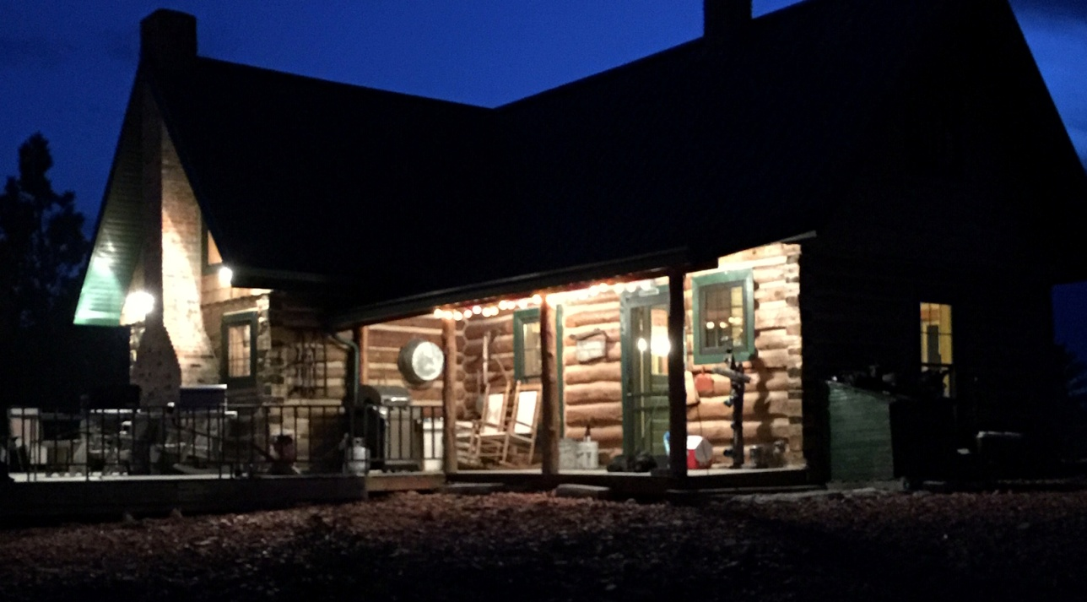

Following that, I started building experimental aircraft. Started by building a set of wings for a friend's Christen Eagle. Finished the Hatz about a year ago and am currently building a 1939 J-3 Cub.
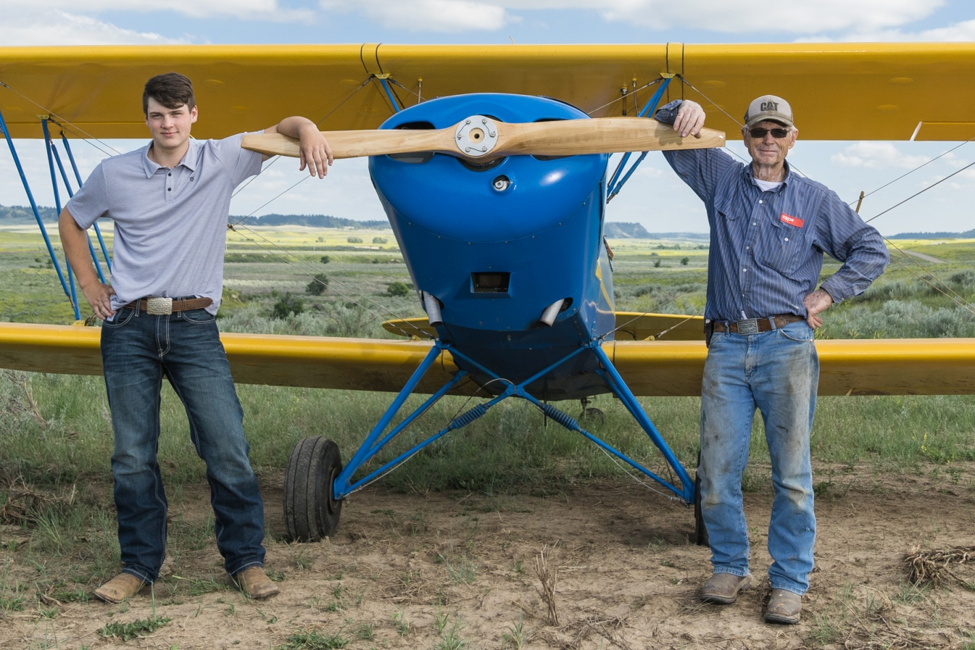
My oldest grandson and I standing in front of a Hatz Biplane that I just recently completed. This particular picture is one of his senior class pictures. Photo by Deborah Kates Fine Photography.

Started the flying gig in ‘67 in a J-3 Cub. Lord willing, I may finish it in a J-3 so the circle is almost complete. It’s been quite a ride, and I’ll never forget the friendships forged in the flying business. Nor will we forget those we left in smoking black holes in SEA. May they RIP.

We’ve been blessed with two sons, their wives, six grandchildren, one great grandchild and another on deck. Family is what it’s all about and we’re glad we were able to do it in Montana.
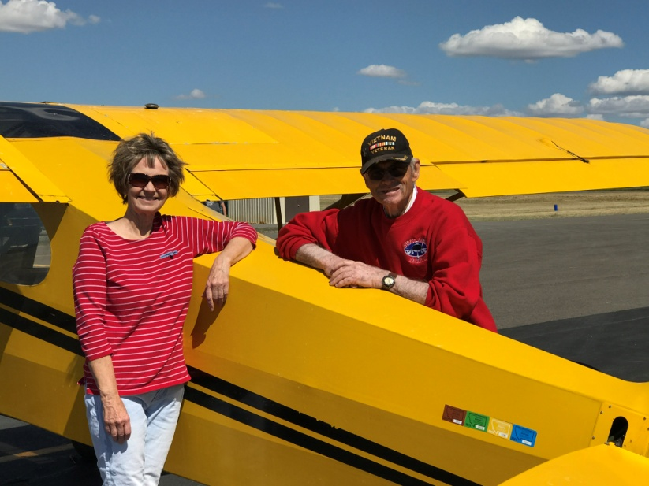  Lee with his wife Linda next to the Super Cub that they purchased when he got out of the Air Force in 1973. It’s still there on the ranch with one total rebuild in 2000 and just into its third engine. Our youngest son Chad flies it as well. | Lee and Linda Howard

A little about Lam Son 719: In late 1970, Allied intelligence discovered vast stockpiles of North Vietnamese Army (NVA) arms and supplies around Tchepone, Laos at the upper end of their infiltration routes into South Vietnam best known as the Ho Chi Minh Trail. Further investigation revealed this was the main supply hub for Communist forces headed south into the Republic of Vietnam.

Military leaders and operational planners agreed the incursion should be of a limited nature, spearheaded by the ARVN, and focused on actions in the southeastern part of “neutral” Laos. The Americans’ role was restricted to providing diversionary, logistical, aviation, and artillery support.

The main objective was the destruction of the enemy’s logistics hub and the prevention of a potential impending offensive by the North’s People’s Army of Vietnam (PAVN). The invasion officially lasted from February 8 to March 25, 1971. It was hoped that they could achieve a swift victory in Laos and reinforce the self-esteem and self-reliance of the ARVN which had grown markedly since their 1970 successes in Cambodia. They also believed it might prove that government forces could defend their nation even as U.S. combat forces continued to drawdown. Lam Son 719 would be a test of the ARVN’s ability to undertake a major combat operation, alone, and justify President Nixon’s policies.

Airpower played an important, but not decisive role, in that it prevented a defeat from becoming a disaster. U.S. Air Force tactical aircraft had flown more than 8,000 sorties during the incursion and had dropped 20,000 tons of bombs and napalm. B-52s had flown another 1,358 sorties and dropped 32,000 tons of ordnance. The Communists brought down seven U.S. fixed-wing aircraft over Laos with six being Air Force and one Navy. Two of the Air Force crew members died and one U.S. Navy aviator. While the resulting destruction of troops and supplies was also significant the strategic effects were temporary at best. In retrospect, it should be clear that leaders in Hanoi were willing to expend as many lives of their own people as necessary and knew they could always count on resupplies from the Soviet Union and the People’s Republic of China in order to continue to fight the war.

Doug’s comments: When I first learned of Lee Howard, I though after they made him they must have thrown away the mold, because he was a fighter pilot who was constantly testing his fate day after day and to accomplish a records number of sorties and combat hours is in itself commendable but he only mentions it in passing. Then after finding out more of this great man and his family I’m convinced they didn’t throw away the mold...I believe he passed that mettle down to his grandchildren. Maybe it’s that Montana Spirit.

Ken Redeker Comes Home To a Real Family Christmas
The spirit of Christmas present fills the home of the John Redeker Jr., family north of
Olpe. The tree is still up, the manger scene is still up, Santa Claus has dominion over the coffee
table, and a warm glow spreads through the house and touches the people within: Kenneth was there for Christmas.

"I believe we needed him to come home worse than he needed to come home," Mrs. John Redeker Jr., says. The Redekers are a clean-scrubbed, hard-working, close-knit farm family., "There are 16 of us, counting us, and our children, and all the grandchildren. We were all glad he could make it home."

"His grandmother was glad he could make it home, too," John Redeker Jr: says. “That's my mother, she's the only grandparent he has left.”

"Oh, yes," Mrs. Redeker agrees. "She, fixed him a feast on Christmas Day. She's prayed hard for him and sent him packages. Says she prays for him every morning when she goes to church.

"But she prays for all her grandchildren, I'm sure."

"That must take all morning," Kenneth Redeker says. "She must have 40 grandchildren."

"Ken" Redeker has a strength about him that would be expected of a farm boy from north of Olpe. His hair is long enough to part, but not so long it interferes with either his vision or hearing. He still seems to be a little unsettled in civilian surroundings — not that he dislikes them, but that he has been away from them so long.
Going back to Vietnam's war zones might seem to be the hardest part of the vacation Emporia's
six vacationing servicemen are having. But, Ken Redeker says, "It won't be as bad as going over the first time.”

"I know what to expect now — I have some friends over there, and I know my job." Mr. Redeker is a mail clerk with the 577 Engineer Battalion; stationed in Vietnam's Central Highlands.

"We're up there pretty high," he says. "Supposedly it's the second highest, mountain in Vietnam, but I don't know..We are up in the clouds and it's actually pretty cool up there where I’m at.” From the heights of the mountain, in Vietnam, down to Saigon, and home to Lyon County, Mr. Redeker encountered a number of temperature changes: from the cool of the mountain, to Saigon, where (he says) the temperature was 85 degrees; to Japan; to Alaska, where the temperature was 3 degrees below zero; to Chicago, notorious for its cold and windy airports; Kansas City, and home. "Somewhere along the way he's picked up a cold," 'his mother says.

Since returning from Vietnam, Mr. Redeker has spent most of his time seeing old friends home
for Christmas from college. "Went hunting yesterday," he says. "Saw four Canadian geese,
but we didn't get any.

"Last night we had an alumni basketball game at Olpe.

"Mostly I've just been seeing family and old friends."

Mr. Redeker's daily work schedule is varied enough and long enough that he seems to have little opportunity for boredom. He opens the company mail room early every morning, then
leaves by armored truck for Phan Rang at 7:30 a.m. or Later.

"It's a little different at the first of the month," he says. "That's when all the guys get paid, and a lot of them want money orders sent home. I've taken down 15, 16 thousand dollars just in a day."

After the money orders are bought and the registered and insured mail signed for, Mr. Redeker and his assistant eat lunch, then wait for the arrival of that day's mail airplane. They help the base mail clerks sort and bag the mail, then run errands for men in the company. They leave Phan Rang at around 2:30," get back to camp around 4 p.m., and sort the mail according to platoons or sections.

Between 5 p.m. and 6 p.m. mail call is held, when each section leader or platoon leader picks up the mail for his men.

After the evening meal, Mr. Redeker returns to the mail room where he forwards mail to men
who have moved on from his company. "I must have a thousand locator cards on men who've been there and gone on," he says. Sometimes, evenings, he attends the showing of "old movies in the old mess hall," as he says. "They're some of them two years old, a lot of them older, and they're all Scotch taped together. But it helps to pass the time for the men."

The truck in which the mail clerk and his assistant go down the mountain to Phan Rang is "Road, Runner," a truck with steel armor sides and machine guns mounted in back. "I have the .60-caliber and the other kid — the assistant mail clerk — has the .50," Mr. Redeker says. "It's supposed to protect us, but I don't know if it would be much help or not."

'Mr. Redeker met Ed Hoyt, who also came home on a vacation from Vietnam, the same day he
learned he would be returned to the states for the holidays.

"When I go down to Phan Rang," he says, "a lot of times the Red Cross field director gives
me messages. This one day I checked with him and he said he had a message. I supposed it was for this guy in the outfit whose wife is expecting. He said, 'No, it's Riedeaker, Reedeaker,
something like that, and I said 'that's me, Redeker.'

"Then he said 'your community is buying you a round-trip airplane ticket so you can go home
for Christmas," -and I said 'Olpe? Olpe is buying my way home? I didn't think Olpe had that much money.’ And I wouldn't want that to sound the wrong way, because I know that lots of people in Olpe helped get me here. But every person in Olpe would have to pay a dollar or two to get that kind of money, and. I hadn't even thought of Emporia doing anything like that."

Mr. Redeker then went to the Base Exchange to do some errands for some of the men in his company. "I saw this kid," he says, "and we both said at the same time, 'I know you!' "It was Ed Hoyt, and he's the first person I ever met over there from back home. We worked together for about a week at the turnpike filling station.

"I thought that was a real miracle — learning I was going to get to come home, and meeting
somebody from home on the same day. And he said he was getting to go back, too."

During the time their airplane was landed at Anchorage, Alaska, Mr. Redeker made a telephone
call to his mother. "I was so excited," she says. "I thought that Alaska was just across the street compared to Vietnam. I wanted io say 'You all just stay here — I'll jump in the car here and go get him.'

"When the station wagon pulled up in front of The Gazette, it seemed like it just exploded. And I didn't see Ken anywhere. Finally he unfolded himself out of the back.

"It's a good thing I hadn't heard that rumor about him being missing. But since he'd called
from Alaska, I really wouldn't have been too worried, I'd have said 'well, if you're looking for
him, look in Alaska, because that's where he was the last time I heard from him.'

"But we're all glad he made it. I really believe we needed him to come home worse than
he needed to be here."

(Emporia Gazette, Emporia, Kansas, December 29, 1971)

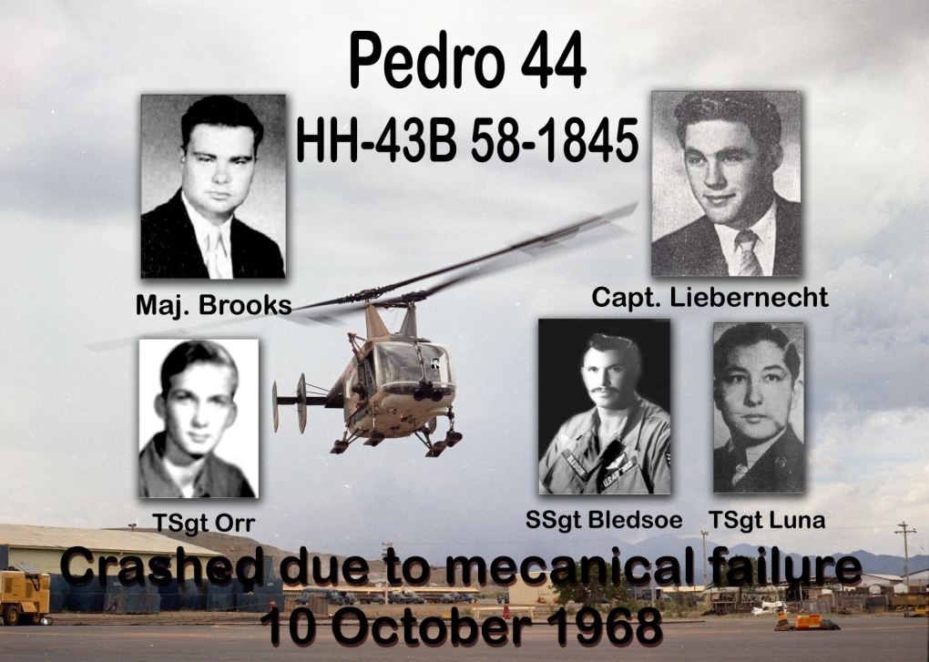

Comments from Facebook
Michael Heffron: I was Security Police Panther flight and was assigned to guard the wreckage that night. Eerie, I have never forgotten. RIP

John T. Weigelt: Watched it from the NCO club. Terrible. Never had a chance.

Jon Buck: For all the firemen attended the crash it was one of the most difficult incidents at Phan Rang in 1968. It the first time we had to carry our own out.

Douglas Farmer: I was there helping, wading in foam up to my knees. Closest I came to death on my whole tour. I was in the crash recovery truck approximately 250 ft away when it fell out of the sky. An experience I shall never forget. 35th FMS crash recovery Aug.68- Aug 69.

Robert Bruce: Douglas Farmer, I was in that truck with you. We were first on the scene but there was nothing that we could do. Pedro was totally engulfed in flames. I still think about it often. Very Sad!

Bob Jaglowski: In 1969-70 I was assigned to the Flight Surgeon's Office in the Dispensary but attached to Det 1, 38 ARRS to a crew as a med tech. Each medic who flew as a med tech on Pedro learned about the tragedy of Pedro 44 on 10 Oct 68. We all reflected on the loss of our brothers at the memorial outside of the Detachment. Rest In Peace Brothers...Slow Hand Salute.

Christopher Boles: 600th Photo shared the same barracks as ARRS. They had the upstairs and we were downstairs. On a few occasions, there were some celebrations of life upstairs that went on for some hours and everyone getting snockered. I asked once what was that all about and they said it was remembering those who perished in this crash. I got there just a couple months after it happened.

Dan Henry:. There are several Pedro People here who will appreciate this. God bless you for what you do for all of Phan Rangers.

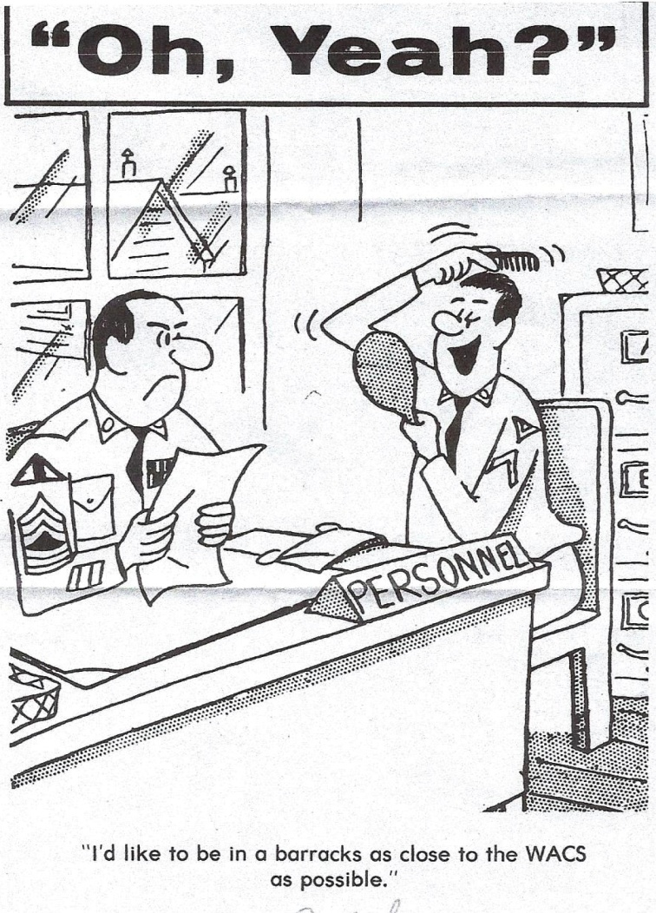

615 Tactical Fighter Squadron, 35 Tactical Fighter Wing,
Phan Rang AB,
Sep 1968

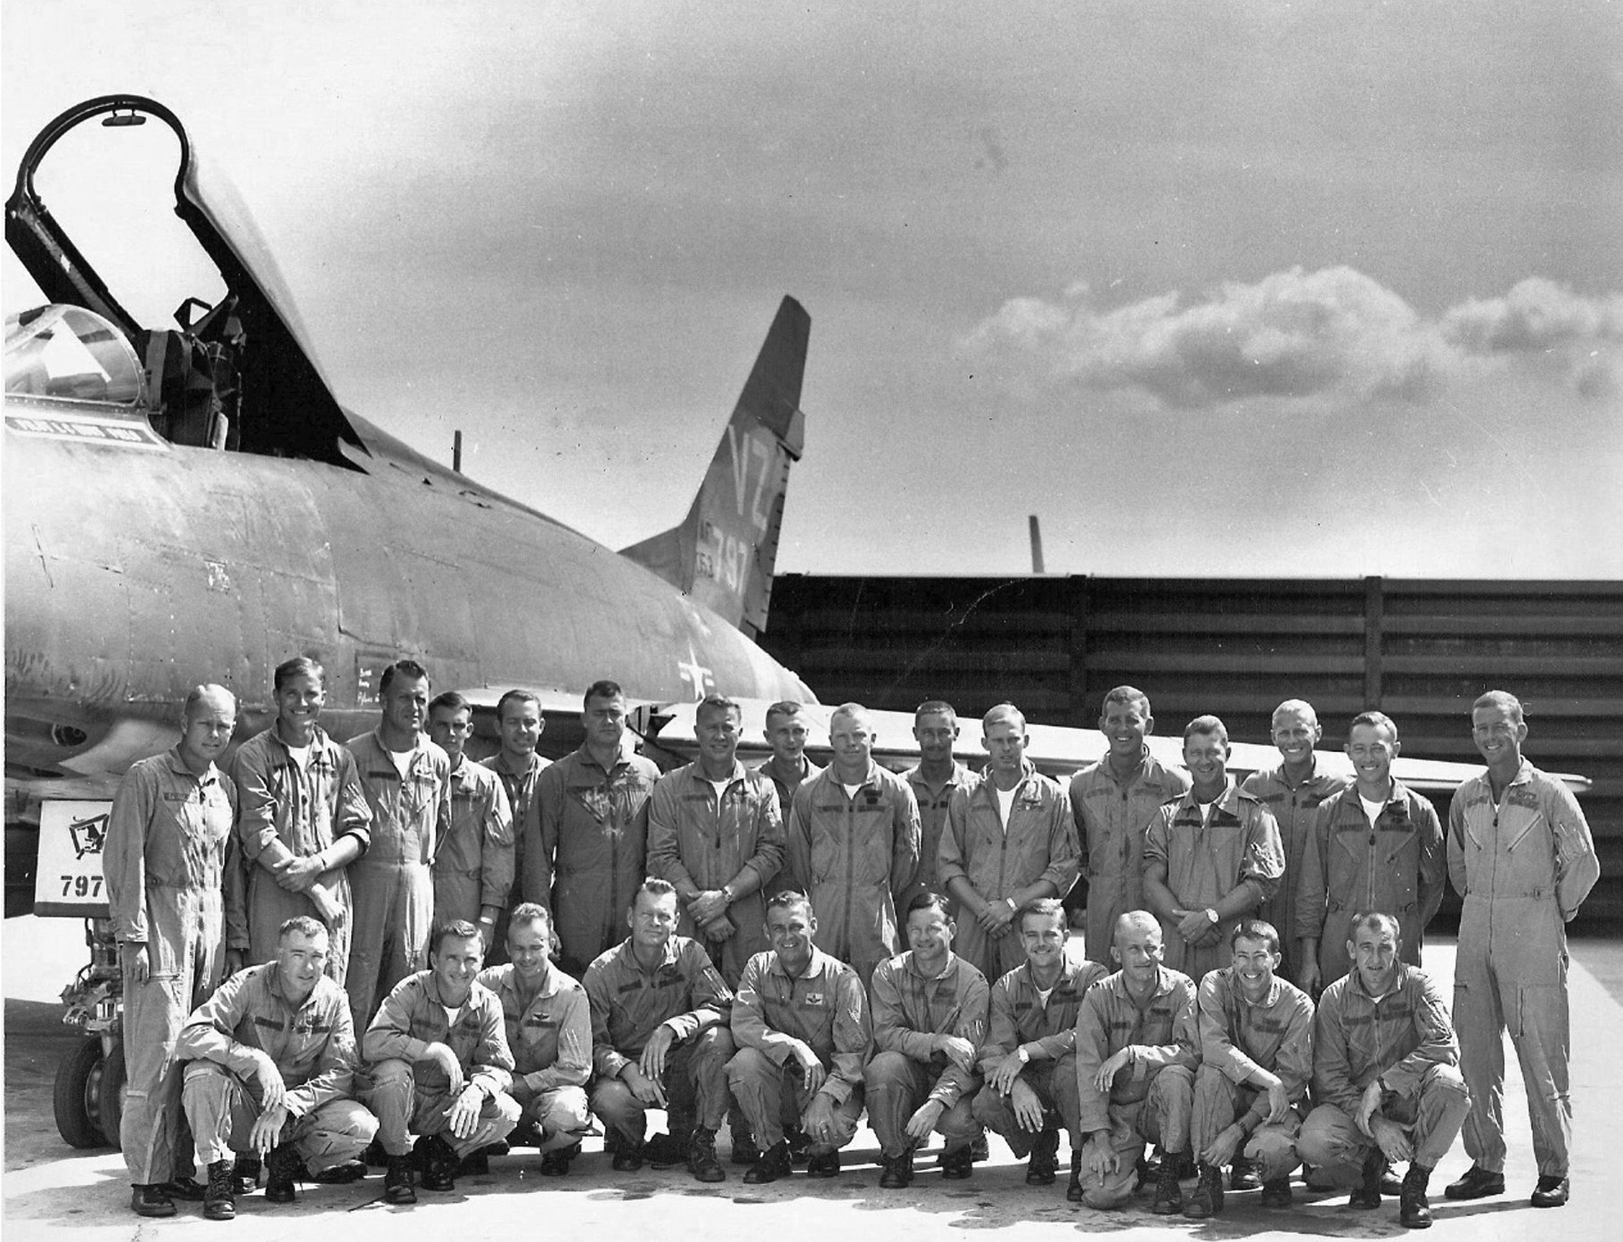
Standing L-R: Bill Davidson, Rich Buickerood, Maj. Eckersley, Jim Thames, Mitt Sanders, Ed LeGrange, Dyrl Crowell, Bill Lamos, Rusty Gideon, Boris Namenuk, Gene O’Baker, Bob Konokpa, Sandy Stymiest, Ron Swanson, Gene Hopp, Win Reither. Photo by Rich Buickerood.

Kneeling L-R: Howard Stevens, Mike Connolly, Greg Butler, Col. Bosworth, LTC McCall, LTC Sam Dickens, Tom Selecman, Dale Tabor, Roger Carroll, Nick Kueber.

“Spooky” Gunship AC-47D Shot Down, 14 Feb 1968
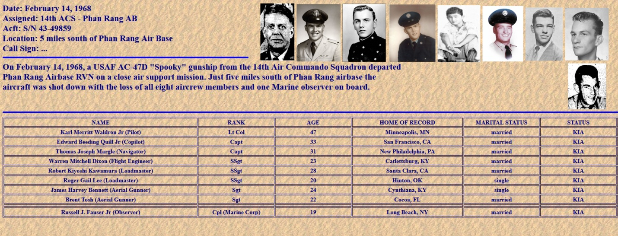

700 Combat Mission
Capt. Ronald F. Miller
Capt. Ronald F. Miller, an F-100 pilot in the 35th Tactical Fighter Wing, Phan Rang AB, Vietnam, flew his 700th combat mission, one of the highest numbers flown by any Air Force pilot in the Vietnam War.

Captain Miller flew 568 missions as a forward air controller during an earlier tour in Vietnam . He returned in his new role after completing training in the supersonic jet fighter.

After flying his 700th mission Captain Miller said: “It feels great. I’ve enjoyed every one of them, and I’m looking forward to getting a lot more before I leave.

(Wichita Falls Sheppard Senator, Wichita Falls, Texas, March 7, 1968)

No. 2 Squadron Strikes by night
THE RAAF’S CANBERRAS IN ACTION IN VIETNAM
PHAN RANG, South Vietnam, Thursday. — Australia's squadron of Canberra jet bombers,
No 2 Squadron, has flown more than 300 missions from this coastal base since arriving
here a little over a month ago.
It is a topsy-turvy war for the Canberra pilots. They sleep by day and bomb by night.

From this US base 165 miles north-east of Saigon, the 500mph jets have attacked targets
all over South Vietnam, from the demilitarized zone to the Vietcong-dominated southern
Delta.

The eight, aircraft, under Wing Commander Rolf Aronsen, of Canberra, have bombarded
Vietcong troop concentrations, base camps, bridges, fortified posts and bunkers with more than 600 tons of explosive.

“I have been extremely pleased with the results", Wing Commander Aronsen said today.

Although the Canberras have done a few four-aircraft formation daylight raids against the Vietcong, they are mainly reserved for highly-specialized ground radar-controlled night strikes.

'Bus runs'
Flying high above antiaircraft fire, the pilots make their runs in total darkness, never seeing the
enemy, with only the red puffs of their bombs landing to remind them they are actually fighting
a war.

And they know only rarely if their bombs have had any effect. The pilots describe their flights
as "bus runs" and find it frustrating that bomb damage assessment is impossible in the dark.
But most of them are pleased that the Canberras once considered obsolete — are now doing
A job of work.

“This is so different from Malaysia", one pilot said.

"We're working for our living now before it was just training and more training".

The Canberras fly seven nights a week, and eight missions are flown each night.

The Australian pilots have been praised for their accuracy with their 500 and 1,0001b Australian-made bombs.

Some fire at Aircraft
On one or two occasions pilots have felt they have scored a direct hit on heavy enemy troop concentrations of up to 500 men, but because ground action has been taking place at the same time, a “kill count" has been impossible.

During the missions the pilots have been subjected to some anti-aircraft fire, but no one has been hit. Some of the fire has been taken close to the Phan Rang air base as the pilots circle in
to land.

One pilot is Flying Officer Peter Hackett, of the Melbourne suburb of St. Kilda. His wife
and two young boys are staying at Ipswich, Queensland.

This morning, sipping coffee in the RAAF operations room at Phan Rang, which sports a plaque
from a United States bomber unit with the inscription "Devil's Own Grim Reapers", Hackett
told the story of the latest mission of the almost 30 he has flown.

His bomber had been loaded at dusk the night before and he was due to take off after midnight.

As arc lights spotted the Canberras in their bays, Hackett sat in the operations room and recorded a tape to his wife as he waited for his turn to fly.

His Canberra was carrying ten 500 pound bombs.

It was to be a routine strike against two targets in the Southern Delta.

With his navigator Flt Lt L. R. "Blue" O'Neill, Hackett walked the short distance to his blue-green
camouflaged jet and prepared for takeoff, shortly after 2am.

"We flew down there at 24,000 feet and then we picked up the ground radar", he said.

Radar guided
'The radar guided us in and we bombed the two Vietcong positions, six bombs on one and four on the other, all in total darkness.
"As the bombs hit we could see the red flashes.

“We had a look to see there were any secondary explosions we didn't actually see what we hit - then we just turned around and came home".

It was daylight when his Canberra landed on the giant Phan Rang strip. Then came an intensive report on the mission— the debriefing followed by a shave and breakfast.

Another routine flight had been completed. It was time to sleep.

As one officer remarked: It looks somewhat odd, to say the least, to see pilots sitting around the operations centre drinking beer at 9am until you realize it's dinner time for them and
they are just having one - for - the -road before going to bed".

(Canberra Times, Canberra, Australian Capital Territory, AU, June 2, 1967)

Big Airlift Ends at Song Be
(Pacific Stars and Stripes, Tokyo, Japan February 19, 1968)
SONG BE, Vietnam (01) —In one of the largest airlifts of the Vietnam war, Air Force tactical transports moved 6,905 tons of troops, equipment, and cargo in 12 days from various bases to Song Be during the first phase of the U.S. Army 101st Airborne Div.’s Operation San Angelo.

Additional tons of cargo were airlifted to resupply units already at Song Be, 75 miles north-northeast of Saigon. The airlift is complete but regular resupply missions to support the ground forces will continue.

The buildup in men and equipment was the prelude to the 101st Airborne's operation to secure the Song Be area.

During the move, the 1st Brigade of the 101st Airborne "Screaming Eagles" was airlifted from Bao Loc, 55 miles northwest of Song Be. At the same time, other airborne troops were flown in from Phan Rang, Phan Thiet and Bien Hoa. Equipment and supplies were also brought in from these three locations, plus Pluioc Vinh, Phu Loi, Cam Ranh Bay AB, and Vung Tau.

Among the equipment and supplies airlifted were fuel, ammunition, food, howitzers, jeeps, trucks, trailers and other heavy equipment.

C-130 Hercules, C-123 Providers and C-7A Caribou tactical airlift aircrews of the 834th Air Division flew 596 sorties in support of San Augelo and another 44 sorties on regular resupply
missions to Song Be. The bulk of the move was done by C-130 aircrews.

The man responsible for the over-all Air Force portion of the airlift, Col. Malcolm P. Hooker,
called Army and Air Force cooperation outstanding.

Air Force teams helped Army personnel prepare loads and weigh equipment the day before the move.

Doug’s Comments: I hope that you enjoyed this newsletter and if you have a story to tell, please write it down and send to me so that your unique experiences can be saved for posterity. This newsletter was composed and all graphics by Douglas Severt unless otherwise stated. To see a list of all previous newsletters click here. To unsubscribe to Phan Rang News, mailto:mailto:mailto:dougsevert@cox.net and put ‘unsubscribe’ in subject line.

