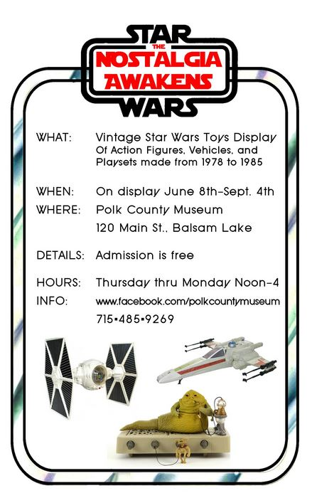
THURSDAY, JUNE 8^{TH,}, 6 P.M. OPENING NIGHT, JOIN THE POLK COUNTY HISTORICAL SOCIETY IN WELCOMING MR. JARROD ROLL, CURATOR AND CREATOR OF THIS EXCITING EXHIBIT. MR. ROLL DISCUSSES HIS COLLECTION AND EXPLAINS HOW IT EVOLVED.
THANKS TO OUR SPONSORS
NOVITZKE, GUST, SEMF, WHITLEY & BERGMANIS ATTORNEYS AT LAW

LAKELAND COMMUNICATIONS

BREMER BANK, NA – AMERY

EXCEL ENERGY

