BRING THEM HOME

Vets for Peace – Military Families Speak Out

WEDNESDAY, MAY 24th
@ 8:37 (Sundown)

FEDERAL BUILDING
BARSTOW STREET
EAU CLAIRE

A memorial reading of the names of those who have died in Iraq

The Color Is Yellow – The Slogan Is “Bring Them Home”

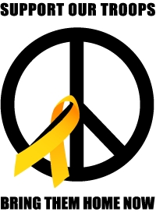

VETS for PEACE

