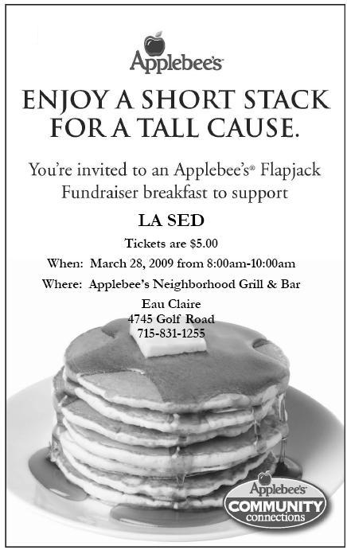

Join us for a PANCAKE BREAKFAST!!!
All proceeds to benefit the community of
El Fortín, Nicaragua.
Tickets can be purchased in advance or at the door.
Questions? Contact Meghan: slugame@uwec.edu
Thank you for your support!

